Exercise 17: Applying MVC

Objective
In this exercise, you’ll learn about apply the Model-View-Controller (MVC) design pattern can be very beneficial to improve the structure and maintainability of your code. The MVC pattern separates the application into three main logical components: the model, the view, and the controller. Each of these components is built to handle specific development aspects of an application.

Exercise
Model: Your model is already defined (Article, Comment model). Models in MVC represent the application's data structure, usually by interfacing with the database. They contain the schema definition and your business logic.
Controller: Create a controller to handle the logic for your routes. This controller will interact with the model to create, read, update, and delete resources.
- Create controllers folder
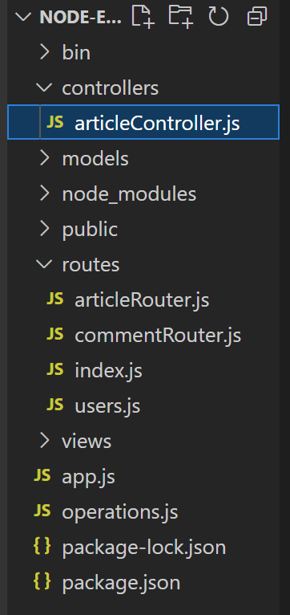
- Create articlesController.js in controllers folder
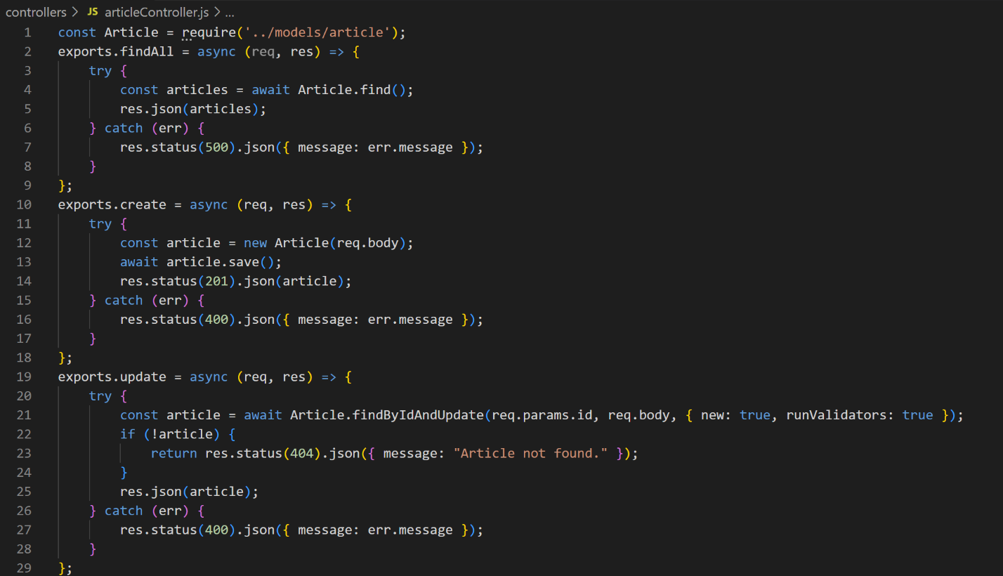

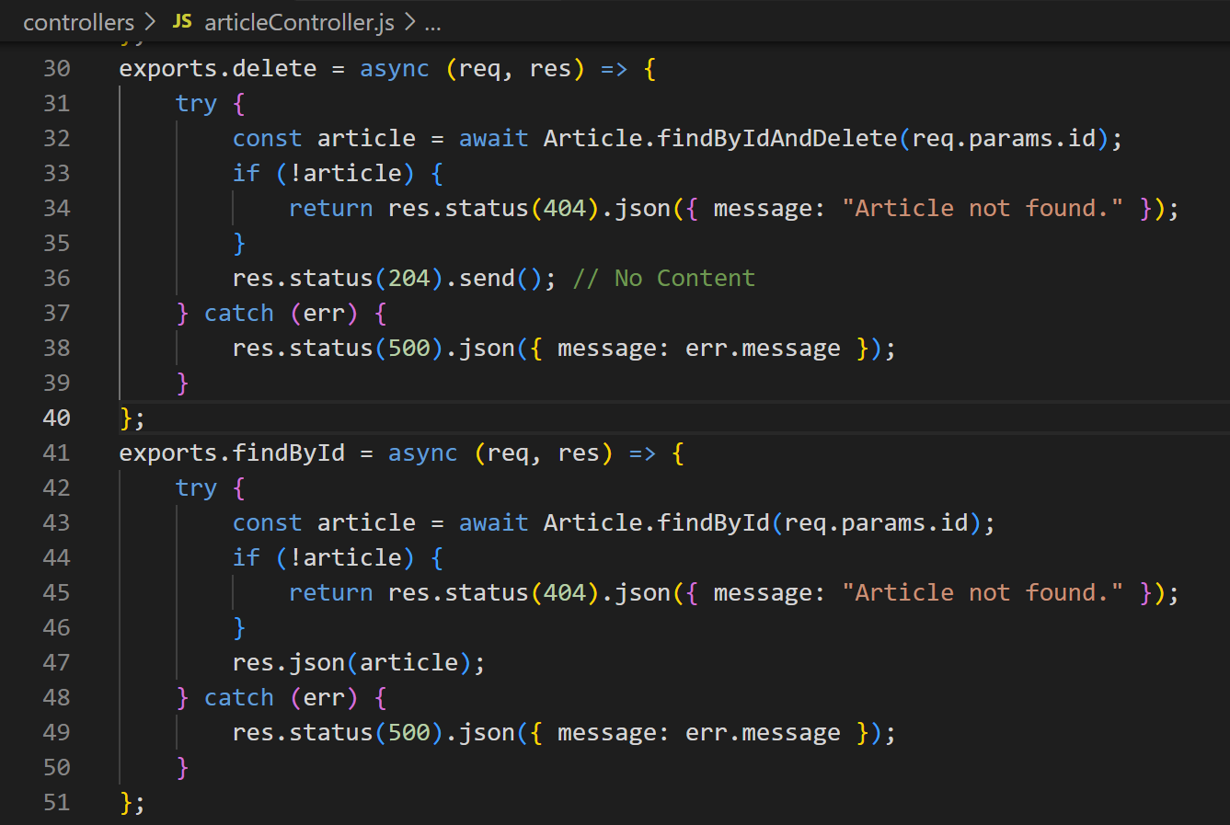

Routes
- Modify your routes to use the controller methods
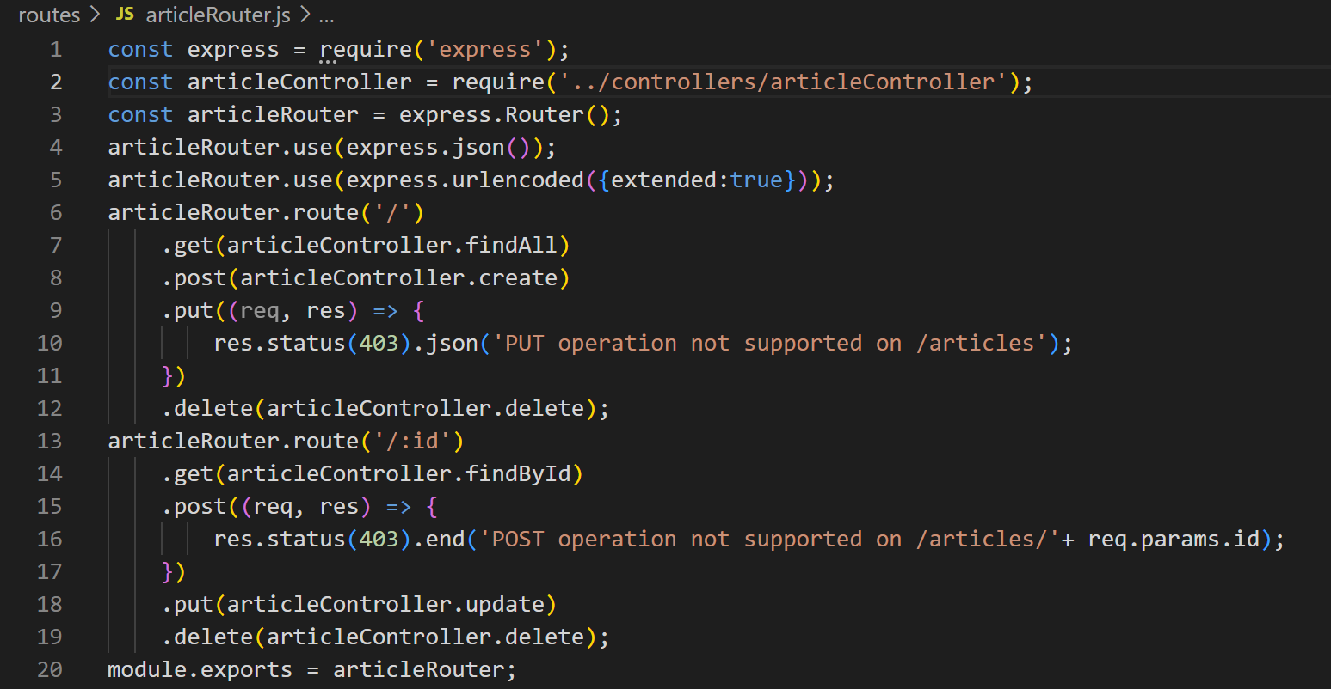
- Test with Postman

Conclusion
After doing this exercise, you are able to improve code organization, maintainability, and scalability basing on MVC pattern.

